Section slides: <http://webdev.slides.com/coltsteele/mysql-106>

# Introduction to Instagram Clone Schema

* In this section we will be cloning a portion of the Instagram database, where we’ll have multiple tables to work with and plenty of opportunities to work on our joins
* Let’s start by designing our schema, which will consist of several entities (not necessarily the same as tables)
  + Users
  + Photos/images (represented as an image URL in this case)
  + Number of likes
    - Need a way to prevent people from adding more than 1 like
  + Hashtags
  + Comments
  + Number of followers that user has
  + Number of people the user is following

# Defining the Users Schema

* The *users* schema will look like this

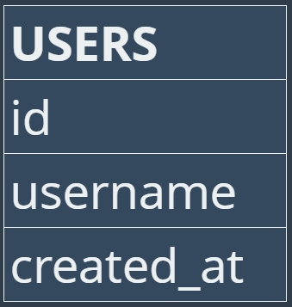

* + The user id is the primary key
  + We want username to be unique as well, but we shouldn’t use it as a primary key because long username strings can take some time to search for. We also want this to be NOT NULL
  + **created_at** will be a timestamp that defaults the current date and time

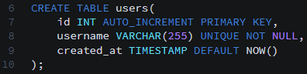

* Let’s add a couple of users so that we can play around with them in this section (the next section will add a huge amount of users)

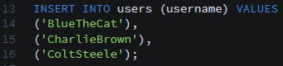

* Code summary

CREATE TABLE users (

id INTEGER AUTO_INCREMENT PRIMARY KEY,

username VARCHAR(255) UNIQUE NOT NULL,

created_at TIMESTAMP DEFAULT NOW()

);

# Defining the Photos Schema

* Here is what our simplified *photos* table will look like, and how it will be connected to *users*

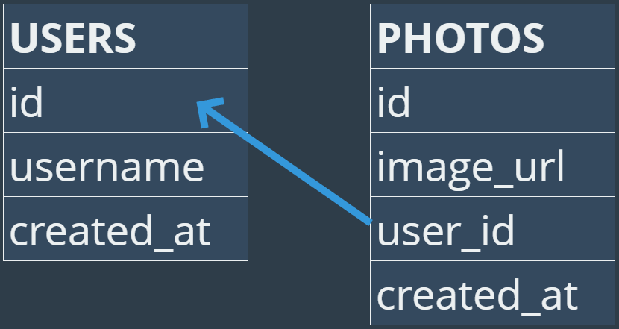

* + We will be using “id” as the primary key, and other tables will reference it
  + The image_url should be NOT NULL so that we don’t have a situation where we have no photo display
  + “user_id” must also be NOT NULL – we do not want to have orphan photos with no users

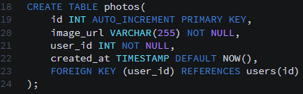

* Let’s insert a couple photos. When adding data to the *photos* table, we will need to supply the **image_url** and **user_id**. The others will auto-populate.

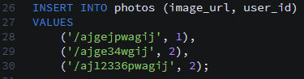

* Code summary

CREATE TABLE photos (

id INTEGER AUTO_INCREMENT PRIMARY KEY,

image_url VARCHAR(255) NOT NULL,

user_id INTEGER NOT NULL,

created_at TIMESTAMP DEFAULT NOW(),

FOREIGN KEY(user_id) REFERENCES users(id)

);

# Creating the Comments Schema

* Comments will rely on users and photos. A comment is authored by someone, and they are attributed to a specific photo
  + This means we will have two foreign keys
* The *comments* table

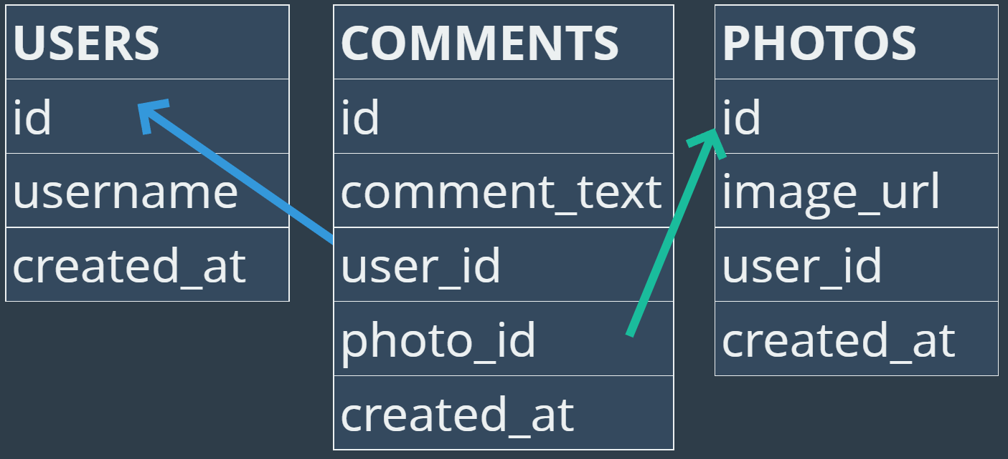

* + The **id** will be the primary key once again
  + **comment_text** cannot be blank. In the real Instagram, a blank comment will not post
  + **user_id** and **photo_id** will both be foreign keys and will both be NOT NULL
    - user­_id will tell us who wrote the comment
    - photo_id will tell us which photo the comment is on

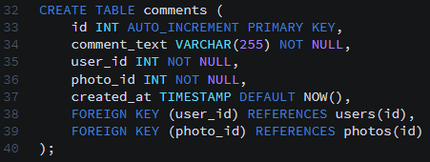

* Let’s insert some data and practice!

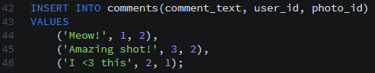

* Code summary

CREATE TABLE comments (

id INTEGER AUTO_INCREMENT PRIMARY KEY,

comment_text VARCHAR(255) NOT NULL,

photo_id INTEGER NOT NULL,

user_id INTEGER NOT NULL,

created_at TIMESTAMP DEFAULT NOW(),

FOREIGN KEY(photo_id) REFERENCES photos(id),

FOREIGN KEY(user_id) REFERENCES users(id)

);

# The Likes Schema

* “Likes” will be somewhat similar to comments. A like must be attributed to the user who is giving the “like”, and must be attributed to the photo being “liked”
* Here’s what the *likes* schema will look like, with the foreign key references

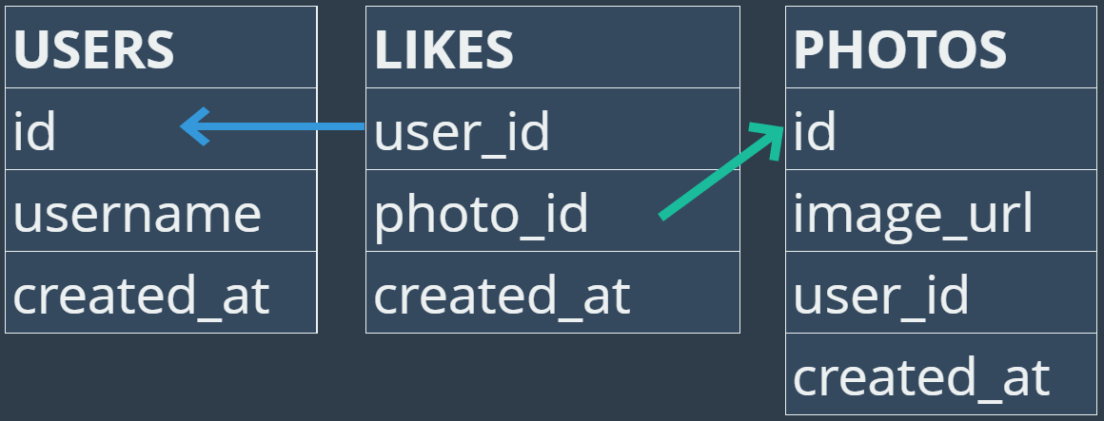

* + In more complicated versions, you could store things like whether the “like” is coming from the web version versus the mobile version
  + Why don’t we have an ID for the likes? It’s because we won’t be referring to unique “likes” in any important manner. Likes refer to other objects, but other tables will not be referring to likes
  + How do we make sure we only have one “like” per user/photo unique combo? This is important because we don’t want to same person to post likes over and over again on the same photo. We can do that by **creating a PRIMARY KEY for the user_id, photo_id combination**
* Putting all that together, here is how we make our table

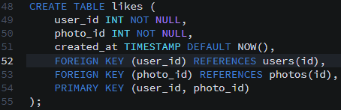

* Optional practice content: having our example people like photos

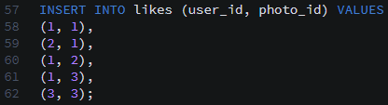

* Now, if you try to give another like with the same user and photo combo, we get an error



* Code summary

CREATE TABLE likes (

user_id INTEGER NOT NULL,

photo_id INTEGER NOT NULL,

created_at TIMESTAMP DEFAULT NOW(),

FOREIGN KEY(user_id) REFERENCES users(id),

FOREIGN KEY(photo_id) REFERENCES photos(id),

PRIMARY KEY(user_id, photo_id)

);

# Relationships

* This refers to relationships between people on Instagram, in terms of users following other users
* We’ll do this in a single table called *follows*, which contains the **follower_id** (the person doing the following) and the **followee_id** (the person being followed). Both will be foreign keys referencing the *users* table.
  + We’ll also use **created_at** to track the date and time
  + We don’t want to have duplicate follows, so the ordered combination of follower_id, followee_id must be unique and occur only once
    - The order is important, because we DO want to allow two people to follow one another in unique follow relationships. We just don’t want the same person to follow the same other person twice
  + We do not need a unique ID in this table, as we won’t be referencing follow relationships from any other tables

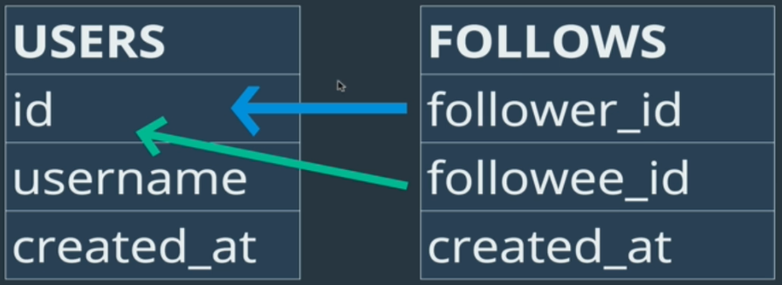

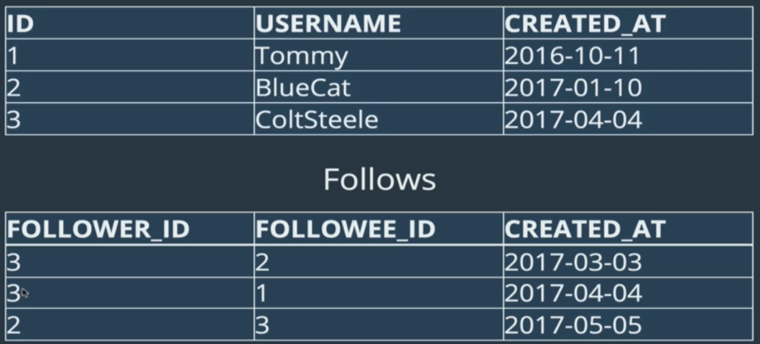

* Verification/practice code: inserting into our tables

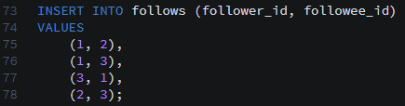

* + Test of database integrity



* Code summary

CREATE TABLE follows (

follower_id INTEGER NOT NULL,

followee_id INTEGER NOT NULL,

created_at TIMESTAMP DEFAULT NOW(),

FOREIGN KEY(follower_id) REFERENCES users(id),

FOREIGN KEY(followee_id) REFERENCES users(id),

PRIMARY KEY(follower_id, followee_id)

);